Shabbos Stories for
Parshas vayetzei 5781
Volume 12, Issue 12 12 Kislev/November 28, 2020
Printed L’illuy nishmas Nechama bas R’ Noach, a”h

For a free subscription, please forward your request to keren18@juno.com
Past stories can be found on the website ShabbosStories.com

The Rebbe’s Medical Diagnosis Of the Ill Yeshiva Student
By Rabbi Tuvia Bolton

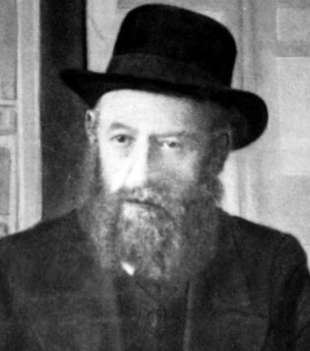

Here is a story about the fifth Rebbe of Chabad, the "Reshab" Rebbe Shalom DovBer (1861-1920.) He wrote thousands of the deepest discourses in the teachings (called Chassidut) of Chabad, established a totally unique Yeshiva (Torah Academy) system (called Tomchi Tmimim) in Russia and fought unrelenting battles to save and strengthen Judaism. But his health was frail, and he regularly had to visit the countryside to rest often on Shabbat.
One such Shabbat while he was a in a cottage few hours distance from the Yeshiva one of the pupils back in the Yeshiva suddenly got a bad case of diarrhea with high fever in the in the middle of the night.

The Fear of Cholera
Now normally this would have aroused only minor interest, but because some years earlier a highly contagious disease called Cholera claimed myriads of lives in Russia and these were the symptoms, everyone was worried.
To make matters worse, the young man refused treatment. The only known treatment at that time was to drink hot tea, which would mean boiling water on Shabbat which is permissible only in life threating cases. He refused to allow them to even ask a non-Jew to light the fire under the water pot on Shabbat!
Only if the Rebbe said it was all right would he agree. After all, it wasn't clear that he had Cholera, and it was too late at night to wake the town doctor to get his opinion.
Someone had to run to the Rebbe, over three hour's walk away, and get him to permit the hot tea. Lots were drawn, and fell on a pupil by the name of Mordechi Perlov (who later became a well know Rabbi in Australia) to rush to the Rebbe for his opinion. He set off at the crack of dawn, running-walking as fast as he could. Over two hours later, drenched with sweat and out of breath, he sighted the Rebbe's cottage.

The Rebbe’s Wife Began to Panic
The Rebbe's wife was sitting on the front porch at the time, and when she saw the young man coming at a rapid pace she began to panic.
"What is it?" she yelled from a distance as she ran to meet him "What is the problem!?"
"Oh, nothing" he said, trying to be calm, hurry, and catch his breath at the same time. "I just want some advice from the Rebbe."
"Tell me what it is!" She demanded "Did something happen in the Yeshiva?"
"Well" he answered reluctantly, still trying to catch his breath, "One of the boys has a fever".
"Only a fever?" She interrogated, "You came running here all the way from the Yeshiva because one boy has a fever?"
"Well, he has a bit of diarrhea too, but it’s nothing too..."
"Oy!" She exclaimed, "It's cholera!!! Come with me. Hurry!"
She rushed him into the house, to the room where the Rebbe was sitting and knocked quietly at the door. There was no reply, so she quietly opened the door and there was the Rebbe, wrapped in his Tallis (prayer shawl), face to the wall preparing to pray. It was obvious that he was in a different world.
"One of the boys has, G-d forbid, Cholera!!" She yelled.
The Rebbe turned, looked at both of them for a few seconds and then motioned with his hand to Mordechi to hear his version.
"Yes Rebbe" he mumbled "Fever and diarrhea"

“No Reason to Get Excited”
"Nuu!" said the Rebbe. "A little diarrhea and fever, it's no reason to get excited" he made a sign indicating that it was nothing and he turned his face back to the wall.
"It's not a little!" Shouted his wife, "Itâ€™s very serious. It's a high fever, and he won't even allow them to ask the gentile worker to make tea for him."
"He's right!" Said the Rebbe, turning back to them, "every time someone has a little diarrhea you have to light fire on Shabbos?" He looked at Mordechai and said calmly, "You go back to the Yeshiva and tell him and everyone else that it is nothing! Do you hear me? Absolutely nothing! He is completely healthy, no matter what the doctor says".
Mordechai turned, rushed out of the cottage, and with wings on his feet, ran back to the Yeshiva.
When he arrived two hours later, almost all the pupils were standing outside saying Psalms, afraid to even be in the building with their stricken friend. The Doctor had been called earlier and he diagnosed Cholera. The boy lapsed into a coma and now it was just a matter of time. Everyone was petrified that it was the beginning of an epidemic.

Threw His Arm Around the Sick Boy
But Mordechi rushed past everyone and into the building ignoring the shouts that he was endangering his life. He went into the sick boy's room, threw his arms around him, hugging him and lifting his limp, unconscious body and said;
"The Rebbe said you are healthy! Get up! The Rebbe said you are healthy!"
The others standing outside heard what he was shouting, and in moments they too entered the building and filled his room and began dancing in the halls.
Suddenly he sick boy, burning with fever, weakly opened his eyes and everyone instantly fell silent as he said;
"Boruch HaShem! (Thank G-d) the Rebbe said I'm healthy."
Minutes later the fever was gone and he was sitting up in bed drinking water. And a week later he was back learning Torah with the rest of his friends as though nothing happened.

Reprinted from the Parshat Chaya Sara 5781 email of Yeshiva Ohr Tmimim of Kfar Chabad, Israel.

The Punishment of
The Czar’s Soldier

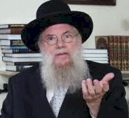
Rav Avrohom Chaim Feuer

The following STORY I heard from HARAV AVROHOM CHAIM FEUER Shlit"a; In Russia, there was once a Chossid who approached his Rebbe the ז''גר and said, "Rebbe, I need Chizuk in Tefillah!"
The Rebbe asked the Chossid "Why do you suddenly need chizzuk in Tefillah?"
The Chossid replied with a story. "Seven years ago, I was passing a courthouse and I heard torturous screams coming from inside the building. Curious to see what was happening, I went inside. I saw how there was young gentile there who was getting heavy lashes on his bare back and was bleeding and screaming in pain.

Why Was the Fellow Being Beaten with Such Heavy Blows
“I went over to one of the people standing by and asked him why this fellow was deserving of such heavy blows. The one I asked explained to me that the fellow was a soldier in the Czar's army, and when he was on duty, one of his ears got frozen solid from the freezing cold.
“Bewildered I asked him, "I do not understand, such loyalty to the Czar that he worked in the ice cold to the extent that his ear froze! I would give this soldier a medal for his devoted work and here he is getting punished for it?!!"
“I could not understand, but he explained it to me. ''You see, he said, when you are working under the Czar, you have the mindset that you are in such awe and trepidation that your blood needs to be bubbling from the fear of the Czar. If a soldier's ear could possibly freeze while working under the Czar of Russia it is a sign that he doesn't realize and comprehend who he is standing in front of."

The Chossid Was Profoundly Inspired by the Explanation
The chossid continued, "After hearing this I thought to myself, if this is the attitude one has live toward the czar a king of flesh and blood all the more so I need to have a feeling a trepidation when I stand in front of the Rebono Shel Oilum when I daven. After this story I had a tremendous chizuk in my Tefillah and when I would daven, I would stand in awe and fear of Hashem, like an eved (servant) stand in front of his master. However, now it is already seven years later, and I feel I need chizuk in my Davening again, so that is why I came to the Rebbe to ask for chizuk in Tefillah.”
THE LESSON: What can we learn from this story? The lesson to be learned is not that our blood needs to come to a boil when we stand in front of Hashem in Tefillah. What we do learn from this story, is an attitude in Tefillah.
True, our ears don't freeze when we daven. We have many other distractions. A phone, for example, can distract someone, or stam, it is very easy to space out. We learn from this story that to space out all the time and be busy with other zachin while standing in front of Hashem is unacceptable and we should think of it as something that is worthy of being lashed for ו''ח .

The Major Difference to Keep in Mind
This soldier was not even standing directly in front of the Czar, whereas when we daven, we are standing Mamesh in front of Hashem. THERE IS A MAJOR DIFFERENCE to keep in mind between working for the Czar and serving Hashem.
Hashem only want to shower us with good and He loves us more than we love ourselves. Therefore, when we stand in front of Hashem in Tefillah it is not just as an eved stand in fear and trepidation in front of his master. Rather it is also like a child standing in front of the most generous, capable, loving and caring Father and Retzono Yisborach L'heitiv2 . Have a great Shabbos and may all of your Tefillos be Niskabel Be'ezras Hashem.

Reprinted from the Parshas Chaya Sarah 5781 email of Eitz Hachayim.
The Visit to the Kever of His Grandmother in Holon

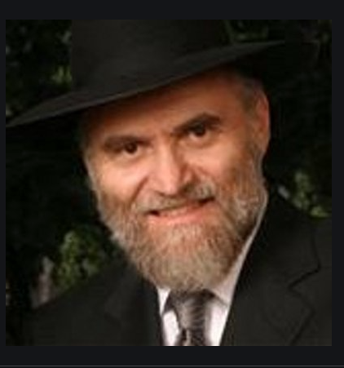

Before one of his overseas trips, a woman asked Rabbi Yerachmiel Milstein, a lecturer in Aish HaTorah’s Discovery Program, if he could take a suitcase to Eretz Yisroel for her. Reb Yerachmiel was happy to do the favor and she was appreciative of his graciousness. R’ Yerachmiel made it to the airport in time. After take-off, he prepared for some of his upcoming meetings at Aish HaTorah, and then sat back and reflected on the possibility of visiting his grandmother’s kever (burial place). R’ Yerachmiel’s grandmother, Rebbetzin Fayga Gnatt a”h, was the daughter of R’ Yerachmiel Yaakov Gnatt zt”l.

A Special Significance in Being
Able to Visit a Grandmother’s Kever
Being able to visit her kever in Cholon held special significance for R’ Yerachmiel, who was named after his great-grandfather. He had been unable to travel to Cholon on his last few trips to Eretz Yisroel, which made him all the more eager to do so now.
On the third day of his trip, R’ Yerachmiel was planning his visit to the cemetery when the doorbell rang. It was Chaim Stern, who came to pick up the suitcase his sister-in-law had sent with R’ Yerachmiel. Chaim and Yerachmiel had never met but they quickly got acquainted.
“So what are your plans for today?” Chaim asked.
“I’m hoping to take care of a few things near the Tel Aviv area,” was the reply.
“No kidding? That’s exactly where I’m headed now. My taxi is waiting for me outside. Maybe you’d like to come along? I would enjoy a companion and there’s a place on the way where you could get off and catch a bus.”

“Just Let Me Grab My Hat”
R’ Yerachmiel always liked to take advantage of unexpected opportunities. “Sure,” he said. “Just let me grab my hat.” About twenty minutes outside of Jerusalem, after a short pit stop to buy a drink, R’ Yerachmiel reached for his wallet. Suddenly, his stomach bottomed out in the free-fall panic known by anyone who has ever forgotten his wallet at home.
R’ Yerachmiel helplessly pictured his wallet sitting on the night table in his bedroom in Har Nof. He didn’t even have any small change in his pocket. He was penniless. He reviewed his options quickly. He could ask Chaim to take him back to Jerusalem. But that would delay Chaim by almost an hour. He could borrow some money from him but Yerachmiel would need enough for bus fares around Tel Aviv and Cholon and back to Jerusalem in the evening. He couldn’t bring himself to ask someone he barely knew for that much money.
Getting back to Jerusalem wasn’t his biggest concern - what really upset him was that there was no way he could visit his grandmother’s kever in Cholon. As this was the only free day of his trip, it meant he would have to forfeit this most meaningful item on his agenda. And who knows how long it would be until he’d be back in Eretz Yisroel again? Waves of disappointment washed over R’ Yerachmiel as he hid his shame and despair behind a false smile.

And Then Came the Dreaded Question
And then came the question R’ Yerachmiel was dreading. “So, what are you planning to do today in Tel Aviv?”
“Well, uh, I, uh, was planning to... visit my grandmother’s kever in Cholon.” R’ Yerachmiel’s voice trailed off as he thought about the visit which he obviously would not be making now.
Chaim sat up abruptly, as if the taxi had stopped short. “You are going to your grandmother’s kever?” he echoed in a whisper.
R’ Yerachmiel nodded, puzzled at Chaim’s response. “You’re going to daven at your bubby’s kever,” Chaim repeated slowly, almost to himself. He turned his face towards the window.
A few moments later he turned back to R’ Yerachmiel with reddened eyes. “Look, would you please do me a tremendous favor?” Chaim begged. Suddenly, he took out his wallet and quickly removed a few bills. He urgently pressed them into R’ Yerachmiel’s palm. “Here’s three hundred shekels. I know you don’t need the money. But please, let me sponsor your trip to the kever. Take taxis wherever you have to go today... on me.”
R’ Yerachmiel was shocked. Chaim swallowed and continued. “My grandparents were all killed in the Holocaust. My parents’ entire families were wiped out without a trace. How I envy you that you even know where your grandparents are buried!” Tears filled his eyes. “I will never have the zechus to daven at my grandparents’ kevarim. If you will accept this money from me, then I might have a small share in the great mitzvah that you are doing today. Please, I realize you hardly know me. But it would mean so much to me if you would accept this money.”
R’ Yerachmiel was speechless. He barely managed to nod his head in agreement.
“Thank you,” Chaim said. “Thank you so much.”
R’ Yerachmiel’s tefillos that day at his grandmother’s kever held even more significance than usual. (Wikler’s Classics by Dr. Meir Wikler.)

Reprinted from the Parshas Chaya Sarah 5781 email of Torah Tavlin.

Rabbi Dovid Cohen’s Incredible Father
By David Bibi

About twenty years ago, I was invited to join and speak with hundreds of the leading outreach professionals in the world in Baltimore. Many of us came for Shabbat. I brought my son Jonah along who was 14 or so at the time.
For each Shabbat meal we sat at large round tables and we were encouraged to change tables for each meal so that we could engage with more of the attendees. The room was filled with these large round tables, each set to seat twelve. At the front of the room, but off to the side though, there was one table set for two. This was a table for Rav Dovid Cohen and his wife. I imagine as he devoted almost all his waking hours to others, Shabbat was the time reserved for the couple.
At lunch on Shabbat though, the table had a third chair. And the chair was occupied by Jonah, who the rabbi invited to join them. We wondered why.
Jonah later told us that the Rabbi wanted to know everything about his life and his perspective on life. He asked about everything and anything. We understood that in being a posek and in deciding for others, one must understand what makes others and the world tick. This was Rabbi Cohen. From everyone can I learn. What a lesson to all of us!
The story is that Rabbi Cohen’s father was a shop keeper on the lower east side. One day back in the 30’s, a women came in and purchased some things. The bill was $6.12. The woman left the money on the counter with Mr. Cohen and thanked him and left the shop. Mr. Cohen picked up the bills, a five and a one and noticed stuck to the one was a ten dollar bill, a huge amount of money in depression times.

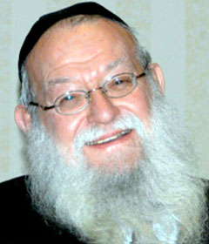
Rabbi Dovid Cohen

Grabbing the ten, he ran out to find the customer and return the money. He looked left and right and saw she was stepping down into the subway line. He ran towards and ddown the stairs. She had already deposited her token and stepped through the turnstile. Mr. Cohen reached into his pocket and was relieved that he too had a token and deposited it and continued the pursuit. He finally caught up to her on the platform. Madam, madam, please wait. She recognized Mr. Cohen and wondered what was wrong. He slipped the ten into her hands explaining it was stuck to the one. She thanked him and stepped onto the subway car which had just opened its doors in front of her.
A week later, she returned to the store. She did her shopping and paid Mr. Cohen awaiting her change. As he was handing her the change, she grabbed his hand, bent her head down and kissed the back of it as Mr. Cohen tried to pull away.
She explained that as she sat on the subway going back up town that day, she couldn’t believe that someone would do such a thing. She returned home and that evening went to see her brother, the head minister at a local church. He too was so impressed given the times and told the story over as part of his sermon on Sunday.
Here he explained was a true descendant of Abraham, a righteous man through whom G-d promised blessings to the world. Here too was a direct descendant of the High Priest Aaron, one given the responsibility to bless others and who’s blessing truly worked. And he told the congregants that if they wanted a blessing in this world, they should all seek out this Mr. Cohen and kiss his hand and they too would be blessed as G-d had sworn.
But every act of Kiddush Hashem we do has the tremendous power to offset these negative messages and to imbue the world around us with holiness. Every time we make the choice to act with decency, kindness and respect, every time we do the right thing, even when it’s hard, we are showing the world what human beings are truly capable of.

Reprinted from the Parshat Ekeb 5780 email of Shabbat Shalom from Cyberspace

The Holy Gardener

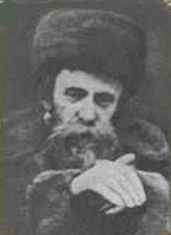

After Rav Ahron Rokeach, the Belzer Rebbe, fled to Eretz Yisrael near the end of World War II, he had to make a decision as to where he was going to settle. He decided on Tel Aviv, and his Hasidim followed him there.
Soon his gabbai noticed that the Rebbe was exhibiting some unusual behavior. He had taken a strong interest in the garden in front of his home, and not only did he instruct the gabbai as to what type of plants should be planted and constantly remind him about trimming the bushes and cutting the grass, but sometimes the Rebbe would even prune the plants himself. Often, he would spend time just marveling at the beautiful garden he had helped to plant.

People walked by and watched in bewilderment as the Rebbe himself weeded the garden and removed dried petals from the beautiful flowers. He even directed the gabbai to purchase all types of gardening tools and to install a shed, giving careful instructions about caring for the plants.
Some thought that perhaps because the world had suffered such a tremendous loss of life the Rebbe felt it was important to value the beauty and splendor of Hashem’s world. But no one dared to question him about his behavior.
They simply assumed that he had his reasons, as he did for everything. At the end of the year, however, Reb Ahron suddenly instructed his gabbai to put away all the gardening equipment. Now it seemed that as quickly as the Rebbe had gained interest in his garden, he had lost interest. What was going on?
Soon everything became clear. The Rebbe explained that it was a shemitah year and, after investing so much effort and energy in his garden, he would now be able to properly observe the laws of shemitah! The Rebbe was adamant – nothing could be touched. Soon the flowers dried out and died, weeds overtook the rest of the garden, and it began to look unkempt.
And the Rebbe? Because he had put so much effort into working on his garden, one might think that the loss of its beauty and bounty would sadden him. Quite the contrary! Every time he saw it, he smiled.
He was fulfilling the will of Hashem. What could be more beautiful? (Touched by a Story 4 by Rabbi Yechiel Spero.)

Reprinted from the Parshat Ekeb 5780 email of Shabbat Shalom from Cyberspace.

Overcoming Life’s Challenges

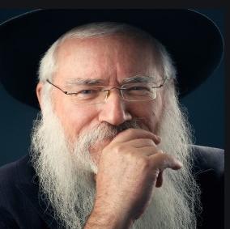

Rabbi Manis Friedman told a story about a time he was invited to speak in Argentina. The flight was from Minnesota to New York, to Chile and then finally to Buenos Aires. He wasn’t a good flyer in general, and this was a particularly difficult flight. His plan was to get picked up and dropped to his hotel so he that he could rest a little so he would be fresh to be able to speak at the event the next morning.
But when he got in the car, the shaliach that picked him up said they had to make a stop on the way. There was a woman in town that had experienced a terrible tragedy and she hadn’t left her apartment in six months. She requested to speak with Rabbi Friedman.
The rabbi felt exhausted after his flight and he was reluctant to go, but the driver had already pulled up to her house, not leaving the rabbi with much of a choice.
When he got to the woman’s apartment, he described her as someone who looked like she had passed away but no one let her know. Her eyes were lifeless, her skin was dull, her voice was monotonous. She was clearly depressed.
She told Rabbi Friedman about how six months ago her son passed away in a car accident at age 19. She told him how he was sweet, kind, and respectful.
The rabbi told her, “It sounds like he was an amazing kid. And you had him for 19 years!”

The Woman was not Impressed
The woman was not impressed. The rabbi asked her, “What if there was no shock? What if Hashem asked you, ‘I have this amazing soul. He needs to be born and live for 19 years. I’m looking for someone to be his mother. Can you do it?’ What would you answer G-d?”
The rabbi was so sure she would say yes, but she answered quickly, “Absolutely not!” Rabbi Friedman said, “Well it’s a good thing G-d didn’t ask you. The woman fell apart and cried her eyes out as if a dam had opened up. All of a sudden she came back to life in front of Rabbi Friedman’s eyes.
When Rabbi Friedman got back in the car, he remembered how annoyed he was that no one had asked him if he could go to the woman. And if they had asked, he would’ve answered, “Absolutely not!” It would have been the wrong answer. He was so moved by the experience.
If Hashem asked people before giving them challenges, we would never amount to anything. The most growth comes from difficult challenges and the most meaningful experiences come with the hardest times. In the end we must know that Hashem loves us like a father loves his children and everything he does for us is only good! Amen!

Hashem’s Challenges Offer Us Great Opportunities
May we always follow in Hashem’s ways and His commandments which are only good for us in this world and will benefit us in the world to come. As we read in the story above, know that all the obstacles and challenges that Hashem sends our way are for us to grow in order to earn our place with the Shechina in Olam Habah!

Reprinted from Parashat Re’eh 5780 email of Jack E. Rahmey as based on the Torah teachings of Rabbi Amram Sananes.

A Confrontation with Titus

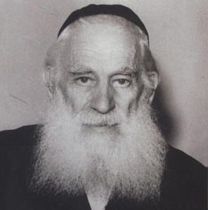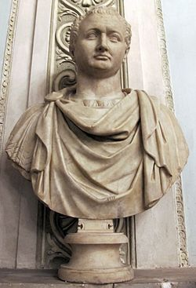
Rav Yosef Kahaneman Statue of Titus

In 1953, The Ponovezher Rav, Rav Yosef Kahaneman, zt”l, spent much of his time traveling to raise funds for his Torah institutions in Eretz Yisroel. On many of his trips, he was accompanied by Dr. Moshe Rothschild. Once, when Dr. Rothschild was studying medicine in Rome, the Ponovezher Rav arrived there late one dark and rainy night.
After checking in to his hotel, the Rav immediately called Dr. Rothschild and asked him to come over and pick him up, as the Rav had somewhere to go to right away. Dr. Rothschild pointed out that it was very late and it was pouring rain outside, “Couldn’t the Rav possibly make this trip tomorrow?” he asked.
The Rav said that it was important for him to go immediately. Dr. Rothschild therefore hired a taxi and went to get the Rav, and was shocked to hear that Rav Kahaneman wanted to go, in the rain, to the Arch of Titus! When they arrived there, the Rav got out of the car and stood in front of the arch— which had carvings of the Bais HaMikdash being destroyed and its holy Keilim (utensils) being looted and plundered.
He shouted, “Titus! Where are you? You thought you would destroy us, and that your Roman empire would last forever! Where are you now? We are still here! We survived you, and we survived the Holocaust, and we rebuilt Torah in Eretz Yisroel! Where is your empire today?! You are dead, Titus! There is nothing left of your mighty empire. But I am here! My people are here! Torah is here! Judaism is alive and continues to live on!”

Reprinted from the Parshas Va’eschanan 5780 email of Torah U’Tefilah as compiled by Rabbi Yehuda Winzelberg.

The Rosh Yeshiva and
The Soda Machine
By Rabbi Avrohom Birnbaum

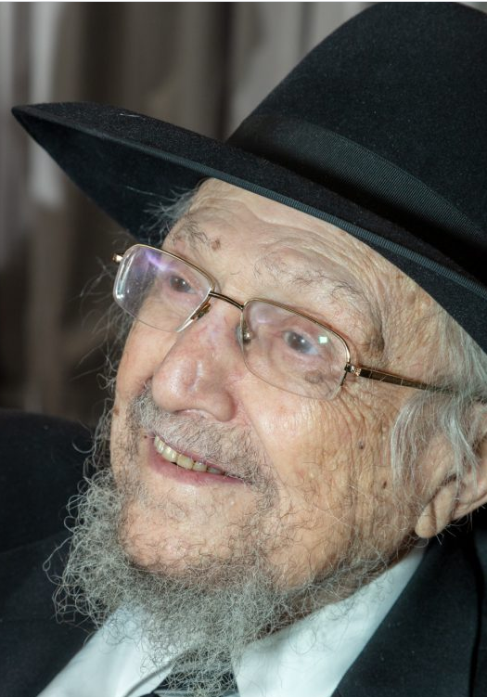
Rabbi Dovid Feinstein, zt”l

On Motzoei Shabbos, I was speaking to my dear friend, Rav Menachem Savitz, who told me a story he experienced with Rav Dovid, illustrating this greatness and showing how Rav Dovid was the antitheses of 2020 culture.
Rav Savitz was working on a sefer on the halachos of nesuin, marriage. He had a whole host of difficult halachic questions on this topic that he wanted to bring to Rav Dovid for clarification. One summer, during bein hazemanim, when the yeshiva was not in session, he went to the Lower East Side to try speaking to the rosh yeshiva. He was hoping to use the quiet time to have his many questions answered.
It was the summer. No one was around and he had the rosh yeshiva to himself. The rosh yeshiva was so friendly and patient as he listened to Rav Savitz’s questions. They spent approximately two hours together.

Opening the Yeshiva’s Soda Machine
During their conversation, something happened that Rav Savitz can never forget. Rav Dovid began walking out of the bais medrash with Rav Savitz following behind. He went into the hallway, pulled a key out of his pocket, and began to open…the soda machine. Before Rav Savitz could even register what was happening, he saw the illustrious rosh yeshiva, a man already in his 80s, filling up Mesivta Tiferes Yerushalayim’s soda machine.
Nearly tongue-tied, Rav Savitz begged the rosh yeshiva, “Please, let me do it.”
With a look of wonder on his face, Rav Dovid exclaimed, “Why should you do it?”
“The rosh yeshiva is a zokein,” Rav Savitz protested. “It is not lefi chevodo (not in accordance with his honor).”

Wasn’t Able to Comprehend the Problem
Rav Dovid again looked at him, innocently, uncomprehendingly, and asked, “Why not? It brings the yeshiva money. What could be not honorable about that?”
Rav Savitz again begged Rav Dovid to please let him fill the machine, but Rav Dovid would not relent and personally finished filling the machine with soda.
Living in this world of 2020, we cannot even begin to fathom such self-effacement, such tzidkus, such pashtus and such gadlus. But for Rav Dovid? That was just him. That was who he was. He didn’t even realize that there was anything remarkable about it. This self-effacement was seen in a man who knew the entire Shas b’yun and is said to have learned Shas hundreds of times.
The contrast between purity, taharas hanefesh and adinus hanefesh, and, lehavdil elef havdalos, the tumah and the shameless self-promotion of accentuating ostensible qualities that don’t even exist is so jarring.
It made me appreciate more and more the towering greatness of the modesty that Rav Dovid exuded.

Reprinted from the November 11, 2020 email of the Yated Ne’eman.

